Canada
Speaking tips
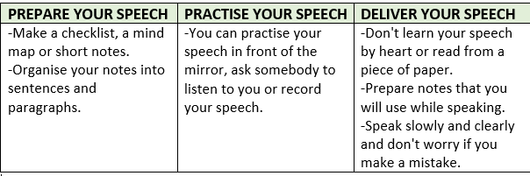
Lista za vrednovanje govora
 | 3 boda | 2 boda | 1 bod
Govorim razgovjetno i bez zastajkivanja.
Točno izgovaram i naglašavam riječi i pravilno intoniram rečenice.
Tema je dobro obrađena: Iznosim sve važne karakteristike o Kanadi.
Koristim širok raspon vokabulara i nove riječi i fraze.
Pravilno koristim glagolsko vrijeme Present Simple, glagolske oblike: biti i imati, množinu imenica, poredak riječi u rečenici.

Example:
Short notes
- the second largest country
- on the continent of North America
- it borders to … to the south and in the north-west
- 90% of Canada - uninhabited
- half of it is covered in …
- national symbols: the beaver, the maple leaf and the Canadian horse
- two official languages: English and …
- Ottawa – capital
Toronto – the largest city
- Montreal – Quebec – French the first official language
- magnificent landscapes: lakes, vast forests, national parks
- most of the polar bears in the world
- Vancouver – on the west coast, the third most popular city
- multicultural city
- different languages
- one of the top ten greenest and cleanest …

