1
WELCOME TO AUSTRALIA
1BA
a) Match and read.
Poveži i pročitaj.

1 caring | preseliti se
2 great-great grandmother | siromašan
3 year  10 | putovanje
4 move | brižan
5 journey | pra-prabaka
6 ship | godina
7 poor | brod

b) Translate the words into English.
Prevedi riječi na engleski jezik.

1 brižan | _______________________
2 pra-prabaka | _______________________
3 siromašan | _______________________
4 putovanje | _______________________
5 preseliti se | _______________________
6 brod | _______________________
7 godina | _______________________

a) Read about Maya’s great-great grandmother with your friend.
2
Pročitaj o Mayainoj pra-prabaki sa svojim prijateljem / prijateljicom.

Abigail Simpson was Maya’s great-great grandmother.
Abigail Simpson je bila Mayaina pra-prabaka.
She was born in Brighton, in the UK.
Ona je rođena u Brightonu, u Ujedinjenom Kraljevstvu.
Her parents were poor and they decided to move to Australia.
Njezini roditelji su bili siromašni i odlučili su se preseliti u Australiju.
They boarded a ship in London.
Ukrcali su se na brod u Londonu.
The journey was long. It lasted 42 (forty-two) days.
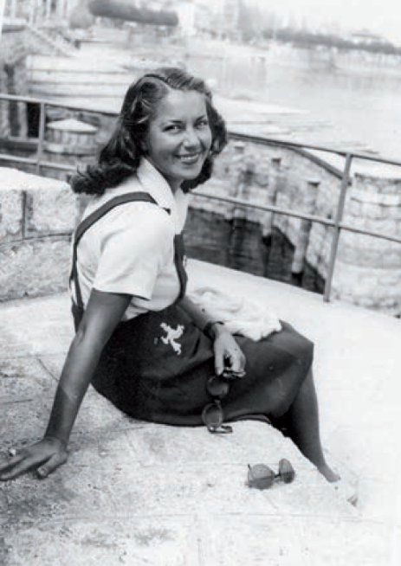
Putovanje je bilo dugo. Trajalo je 42 dana.
They arrived in Sydney in 1919.
Stigli su u Sydney 1919.
Abigail lived in Sydney for 30 (thirty) years.
Abigail je živjela u Sydneyu 30 godina.
She worked as a teacher for 40 (forty) years.
Radila je kao učiteljica 40 godina.
Maya’s mum loved her very much.
Mayina mama ju je jako voljela.
She was a fun and caring grandma.
Bila je zabavna i brižna baka.

b) Match the right answers.
Poveži točne odgovore.

1 Abigail was | 1 | a teacher.
2 She was born |  | Maya’s great-great grandmother.
3 Her parents were poor and |  | Sydney in 1919.
4 They arrived in |  | they decided to move to Australia.
5 Abigail was |  | in Brighton, in the UK.

c) Copy the correct sentences from Exercise 2 b).
Prepiši točne rečenice iz zadatka 2. b).

1 Abigail was Maya’s great-great grandmother.
2 ________________________________________________.
3 ________________________________________________.
4 ________________________________________________.
5 ________________________________________________.

d) Translate the sentences from Exercise 2 c) into Croatian.
Prevedi rečenice iz zadatka 2. c) na hrvatski jezik.

1 Abigail je bila Mayina pra-prabaka.
2 ________________________________________________.
3 ________________________________________________.
4 ________________________________________________.
5 ________________________________________________.
3
Read the sentences. Circle the sentences that are about the past events.
Pročitaj rečenice. Zaokruži rečenice koje govore o događajima iz prošlosti.
1 | a) | They move every year.  Oni se sele svake godine.
 | b) | We moved last week.  Mi smo se preselili prošli tjedan.
2 | a) | They always board a ship in London.  Oni se uvijek ukrcaju na brod u Londonu.
 | b) | We boarded a ship in London last year.  Mi smo se ukrcali na brod u Londonu jučer.
3 | a) | The plane from London arrives at five in the afternoon.  Avion iz Londona stiže u pet popodne.
 | b) | We arrived in Sydney last week.  Mi smo stigli u Sydney prošli tjedan.
4 | a) | My mum works as a teacher.  Moja mama radi kao učiteljica.
 | b) | My great-great grandmother worked as a teacher for 40 years.  Moja pra-prabaka je radila kao učiteljica 40 godina.
5 | a) | My mum loves me very much.  Moja mama me jako voli.
 | b) | My mum loved my great-great grandmother very much.  Moja mama je je jako voljela svoju pra-prabaku.

PAST SIMPLE – regular verbs

My…
GRAMMAR!
PAST SIMPLE – pravilni glagoli
Glagolsko vrijeme past simple koristimo za izražavanje radnji koje su se dogodile u prošlosti.

LOOK AND READ!
Glagolsko vrijeme past simple tvorimo dodavanjem nastavka –ed na glagol.
The journey lasted 40 days.  Put je trajao 40 dana. | last + -ed = LASTED
She worked as a teacher.  Radila je kao učiteljica. | work + -ed = WORKED
PAZI!
1 Ako glagol završava na –e, glagolu dodajemo samo nastavak –d:
She moved to Melbourne.  Preselila se u Melbourne. | move + –d = MOVED
2 Neki glagoli udvostručavaju završni suglasnik pri dodavanju nastavka –ed:
She never stopped telling stories.  Nikad nije prestala pričati priče. | stop + –ed = STOPPED
3 Ponekad se y na kraju glagola mijenja u i pri dodavanju nastavka –ed:
She cried all the time.  Plakala je cijelo vrijeme. | cry + –ed = CRIED

Nastavak –ed koji dodamo glagolu može se izgovarati / d /, / t / ili / id /.

a) Listen and repeat the verbs. Pay attention to how you pronounce –d and –ed.
3
Slušaj i ponovi glagole. Obrati pažnju na to kako izgovaraš nastavke –d and –ed.

/ d / | / t / | / id /
moved | jumped | lasted
cried | worked | decided
died | talked | boarded

b) Write the past simple forms of the verbs. Read them to your teacher.
Napiši past simple oblik glagola. Pročitaj ih svojoj učiteljici.

1 work  raditi | he ____________  on je radio | 5 decide  odlučiti | they ____________  oni su odlučili
2 board  ukrcati se | they ____________  oni su se ukrcali | 6 stop  prestati | she ____________  ona je prestala
3 move  preseliti se | she ____________  ona se preselila | 7 love  voljeti | they ____________  oni su voljeli
4 cry  plakati | we ____________  mi smo plakali | 8 arrive  stići | he ____________  on je stigao

c) Complete the sentences with the words in the box.
Dopuni rečenice s riječima iz kućice.

played moved loved worked married lived

1 Samuel Simpson was Maya’s great-great grandfather.
Samuel Simpson je bio Mayin pra-pradjed.
moved
2 He _________________ (move) to Sydney when he was 15 (fifteen).
On se preselio u Sydney kad je imao 15 godina.
3 He _________________ (play) rugby for a rugby club in Sydney.
On je igrao ragbi za ragbi klub u Sydneyu.
4 He _________________ (work) as a maths teacher.
On je radio kao učitelj matematike.
5 He _________________ (marry) Abigail.
On je oženio Abigail.
6 They _________________ (live) happily together for many years.
Zajedno su živjeli sretno mnogo godina.
7 They _________________ (love) their children and grandchildren.
Oni su voljeli svoju djecu i unuke.

d) Tell your teacher everything you remember about Samuel Simpson.
Reci učiteljici sve čega se sjećaš o Samuelu Simpsonu.

