1
a) Read the sentence and circle the correct word.
Pročitaj rečenicu i zaokruži točnu riječ.
Blind people can / canʼt see.
Slijepi ljudi mogu / ne mogu vidjeti.

b) Point and read with your teacher.
Pokaži i pročitaj sa svojom učiteljicom.
1 a sound signal | 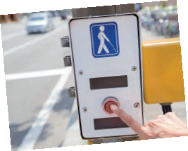
2 the Braille alphabet | 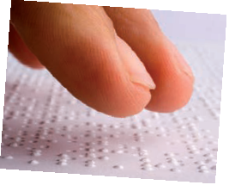
3 tenji blocks and a white cane | 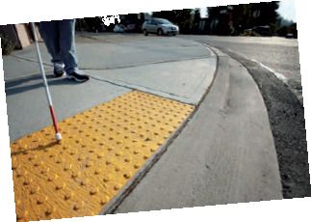
2
Read the words once again. Try to remember what they mean in Croatian.
Pročitaj riječi još jednom. Pokušaj zapamtiti što znače na hrvatskom jeziku.
1 sound signal  2 Braille alphabet  3 tenji blocks  4 white cane | zvučni signal  Brailleovo pismo  tenji blokovi  bijeli štap

a) Read about Benʼs brother David. Look at the words in red. Find and circle the
words in English that have the same meaning.
3
Pročitaj o Benovom bratu Davidu. Pogledaj crvene riječi. Pronađi i zaokruži riječi na
engleskom jeziku koje imaju isto značenje.

My brother David is my favourite person in the world.
Moj brat David je moja najdraža osoba na svijetu.
He is four years older than me.
On je četiri godine stariji od mene.
He was born blind.
Rođen je slijep.
Still, he does sport.
Ipak, bavi se sportom.
He goes rowing three times a week.
On vesla tri puta tjedno.
His favourite activity is reading.
Njegova najdraža aktivnost je čitanje.
He usually reads books in Braille.
Obično čita knjige na Brailleovom pismu.
Sometimes he listens to audiobooks.
Ponekad sluša audio knjige.
He has got a guide dog, Molly.
On ima psa vodiča, Molly.
He likes hanging out with his friends.
Voli se družiti s prijateljima.
He is quite independent.
Vrlo je neovisan.
b) Circle the correct answer. Read the sentences to your teacher. Then translate
them into Croatian.
Zaokruži točan odgovor. Pročitaj rečenice svojoj učiteljici. Zatim ih prevedi na hrvatski
jezik.
1 David | a) is younger than Ben.  b) is older than Ben.
2 David | a) can read Braille.  b) canʼt read Braille.
3 David | a) likes hanging out with his friends.  b) doesnʼt like hanging out with his friends.
4 David | a) isnʼt independent.  b) is independent.

c) Read the questions about David. Complete the answers with the words from the
box.
Pročitaj pitanja o Davidu. Dopuni odgovore riječima iz kućice.
audiobooks rowing a guide dog reading brother

1 Who is David? | David is Ben's ______________.  brother
2 What sport does David do? | David goes ______________.
3 What is his favourite activity? | His favourite activity is ______________.
4 What does he listen to? | He listens to ______________.
5 Who is Molly? | Molly is ____________________.
a) Translate the missing words into Croatian. Check with your friend.
4
Prevedi riječi koje nedostaju na hrvatski jezik. Provjeri sa svojom prijateljicom / svojim
prijateljem.
Monday | _____________  ponedjeljak | school | ________________
Tuesday | _____________ | hairdresser | ________________  frizer
Wednesday | _____________  srijeda | dentist | ________________  zubar
Thursday | _____________  četvrtak | vet | ________________
Friday | _____________ | science museum | ________________  prirodoslovni muzej
Saturday | _____________ | shopping | ________________
Sunday | _____________ | concert | ________________

b) Look at the table from Exercise 5 a) and complete the sentences. Write what
David is doing each day of the week.
Pogledaj tablicu u zadatku 5. a) i nadopuni rečenice. Napiši što će David raditi svaki
dan u tjednu.
is going to
1 David _______________ school on Monday.
2 He _______________ to the hairdresser on Tuesday.
3 He _______________ to the dentist on Wednesday.
is taking
4 He _______________ Molly to the vet on _______________.
5 He is going to the science _______________ on Friday.
6 He _______________ shopping on Saturday.
7 He is going to a concert on _______________.
Present continuous for the future
Glagolsko vrijeme present continuous za izražavanje budućnosti

Glagolsko vrijeme present continuous koristimo za unaprijed ugovorene radnje u skoroj budućnosti.
LOOK AND READ! | POGLEDAJ I PROČITAJ!
What are you doing on Saturday morning?  I am going to the pool. | Što ćeš raditi u subotu ujutro?  Ići ću na bazen.
Are you visiting your grandma on Sunday?  No, Iʼm not.  She is visiting us. | Hoćeš li posjetiti svoju baku u nedjelju?  Ne, neću.  Ona će posjetiti nas.
5
Look at what is Ben going to do next week. Write full sentences.
Pogledaj što će Ben raditi idući tjedan. Napiši cijele rečenice.
1 Monday - is seeing a doctor
He is seeing a doctor on Monday.
_______________________________________________
2 Tuesday - is doing a project
He __________________________________ on Tuesday.
3 Wednesday - is writing a book report
_______________________________________________
4 Thursday - is going to the gym
_______________________________________________
5 Friday - is going to the cinema
_______________________________________________
6 Saturday - is doing homework
_______________________________________________
7 Sunday - is visiting a friend
_______________________________________________
6
Write three things that you are doing next week. Report to your teacher.
Napiši tri stvari koje ćeš raditi sljedeći tjedan. Reci učiteljici.
0 I am going to school on Monday.
1 I am _________ing _________________________________________
2 _________________________________________________________
3 _________________________________________________________

