1
a) Match the sport with the picture. Read to your teacher.
Poveži sport i sliku. Pročitaj učiteljici.

1 handball

2 basketball

3 football

4 volleyball

b) Translate the words into English.
Prevedi riječi na engleski jezik.
1 rukomet | ______________________________________
2 nogomet | ______________________________________
3 odbojka | ______________________________________
4 košarka | ______________________________________

c) Do you play dodgeball with your friends? Report your teacher.
Igraš li graničare sa svojim prijateljima? Kaži svojoj učiteljici.

Look at the words and pictures. Copy the words in English on the empty lines.
2
Pogledaj riječi i slike. Prepiši engleske riječi na prazne crte.

1 gymnastics | 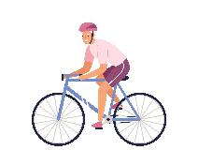  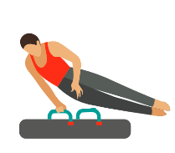 | ________________ | gimnastika
2 cycling |  | ________________ | biciklizam
3 athletics | 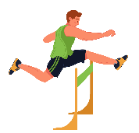 | ________________ | atletika
4 judo | 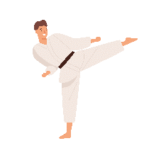 | ________________ | džudo
5 ice hockey |  | ________________ | hokej na ledu
6 rowing | 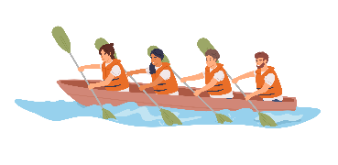 | ________________ | veslanje

3
What are your favourite sports? Write your five favourite sports in English and in Croatian.
Koji su tvoji omiljeni sportovi? Napiši pet najdražih sportova na engleskom i hrvatskom jeziku.
1 _______________________ | _______________________
2 _______________________ | _______________________
3 _______________________ | _______________________
4 _______________________ | _______________________
5 _______________________ | _______________________
a) Answer the questions. Use: Yes, it is. or No, it isnʼt.
4
Odgovori na pitanja. Upotrijebi Yes, it is. ili No, it isnʼt.
1 Is dodgeball your favourite sport?  Jesu li graničari tvoj omiljeni sport? | _______________
2 Is volleyball your mum’s favourite sport?  Je li odbojka omiljeni sport tvoje mame? | _______________
3 Is karate your friendʼs favourite sport?  Je li karate omiljeni sport tvog prijatelja? | _______________
4 Is football your dadʼs favourite sport?  Je li nogomet omiljeni sport tvog tate? | _______________
5 Is rowing your grandfatherʼs favourite sport?  Je li veslanje omiljeni sport tvojeg djeda? | _______________

b) Look at Exercise 4 a) and write five sentences about favourite sports.
Pogledaj zadatak 4. a) i napiši pet rečenica o omiljenim sportovima.
1 Dodgeball ____________ my favourite sport.
2 Volleyball _____________________________________________.
3 _____________________________________________________.
4 ______________________________________________________.
c) Tell your teacher about your family members’ favourite sports.
Reci svojoj učiteljici o omiljenim sportovima tvojih članova obitelji.

a) Answer the questions. Circle the correct answer.
5
Odgovori na pitanja. Zaokruži točan odgovor.

1 Is she playing football?  Igra li ona nogomet? |  | YES | NO
2 Are they going rowing?  Veslaju li oni? |  | YES | NO
3 Is he doing judo?  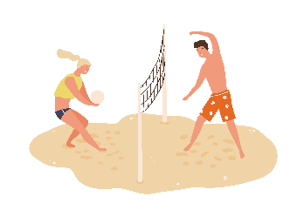  Vježba li on judo? |  | YES | NO
4 Are they playing volleyball?  Igraju li oni odbojku? |  | YES | NO
5 Are they doing any sport?  Bave li se oni nekim sportom? |  | YES | NO

b) Read the questions from Exercise 5 a) again. Then complete the answers.
Ponovno pročitaj pitanja iz zadatka 5. a). Zatim dopuni odgovore.
1 Yes, she is ______________ football.
2 Yes, they are ______________ rowing.
3 Yes, he is ______________ karate.
4 Yes, they are ______________ volleyball.
5 No, they are not ______________ any sport.
6
Ask your friend to read the questions from Exercise 5 a). Point to the correct pictures and answer as many questions as you can.
Zamoli prijatelja / prijateljicu da pročita pitanja iz zadatka 5. Pokaži na točne slike i odgovori na što više pitanja.
Present continuous
Glagolsko vrijeme present continuous

Glagolsko vrijeme present continuous koristimo za radnje koje se događaju upravo sada.
LOOK AND READ! | POGLEDAJ I PROČITAJ!
What are they doing now? | Što oni rade sada?
I am playing tennis.  My friend isn't playing tennis.  She is swimming. | Ja igram tenis.  Moja prijateljica ne igra tenis.  Ona pliva.
We are doing judo.  They aren't doing judo.  They are doing karate. | Mi vježbamo džudo.  Oni ne vježbaju džudo.  Oni vježbaju karate.

7
What is happening right now? Complete the sentences with the verbs from the box.
Što se događa upravo sada? Dopuni rečenice s glagolima iz kućice.
playing going doing watching playing

playing
1 My friends are not at home, they are __________________ handball.
Moji prijatelji nisu kući, igraju rukomet.
2 We are on the lake, we are __________________ rowing.
Mi smo na jezeru, idemo veslati.
3 She is at the gym, she is __________________ karate.
Ona je u dvorani, ona trenira karate.
4 My dog is __________________ with a ball by the lake.
Moj se pas igra loptom pokraj jezera.
5 My grandpa is at home, he is __________________ TV.
Moj djed je kući, on gleda TV.
8
Complete the sentences. Use am, is or are.
Dopuni rečenice. Upotrijebi am, is ili are.
1 Look at my friend! He __________ doing athletics. He __________
running fast.
2 Two girls from my class are in the gym now. They __________ playing
volleyball.
3 I __________ not doing any sport now, I __________ playing with my dog.
4 We __________ playing football.
9
Where are you? What are you doing at the moment? Write, then tell your teacher.
Gdje si? Što trenutno radiš? Napiši, a zatim reci učiteljici.

I am _____________________________________________________
_________________________________________________________

