3AA
THE HISTORY OF DOWN UNDER
1
a) Write the numbers from 1 to 20.
Napiši brojeve od 1 do 20.
20
 | ____  13 | twenty | ____ | fifteen
 | ____ | thirteen | ____ | four
 | ____ | five | ____ | sixteen
 | ____ | eleven | ____ | ten
 | ____ | two | ____ | five
 | ____ | twelve | ____ | three
 | ____ | eight | ____ | seven
 | ____ | seventeen | ____ | nine
 | ____ | eighteen | ____ | nineteen

b) Copy the numbers from Exercise 1 a) in the correct order.
Prepiši brojeve iz zadatka 1. a) po redu.
2 two
1 one
 | ____________ | ____________ | ____________ | ____________
 | ____________ | ____________ | ____________  7 seven | ____________
 | ____________ | ____________  14 fourteen | ____________ | ____________
 | ____________ | ____________ | ____________ | ____________  20 twenty
 | ____________ | ____________ | ____________ | ____________

c) Match the numbers. Then read them with your teacher.
Poveži brojeve. Zatim ih pročitaj sa svojom učiteljicom.

1 | 10 | ____ | forty
2 | 20 | ____ | ninety
3 | 30 | ____ | eighty
4 | 40 | ____ | fifty
5 | 50 | ____ | thirty
6 | 60 | ____  1 | twenty
7 | 70 | ____ | ten
8 | 80 | ____  10 | forty
9 | 90 | ____ | hundred
10 | 100 | ____  11 | seventy
11 | 1000 | ____ | thousand

d) Copy the correct numbers from the box. Read them to your teacher.
Prepiši točan broj iz kućice. Pročitaj ih svojoj učiteljici.

48 63 29 82 35 53

1 sixty-three | _____ |  | 4 fifty-three | _____
2 thirty-five | _____ |  | 5 eighty-two | _____
3 forty-eight | _____ |  | 6 twenty-nine | _____

SAYING YEARS

My…
EVERYDAY ENGLISH!
KAZIVANJE GODINA
LOOK AND READ!
When you are saying years, divide the year into two parts and say the two numbers.
Kad kazuješ godine, podijeli godinu (broj) na dva dijela i reci dva broja.
1788. godina
17 88

seventeen | eigty-eight
1770. godina
17 70
seventeen | seventy
1986. godina
19 86

nineteen | eighty-six
1901. godina
19 01

nineteen | oh one
BUT! 300 – three hundred
2000 – two thousand
2005 – two thousand and five

Pogledaj primjere i zaokruži točno rješenje.
U hrvatskom jeziku iza godine stavljamo / ne stavljamo točku.
U engleskom jeziku iza godine stavljamo / ne stavljamo točku.
a) Match the years. Then read the years with your teacher.
2
Poveži godine. Zatim pročitaj godine sa svojom učiteljicom.

1 seventeen seventy | ______ | 1153
2 twelve thirty-five | ______  1 | 1899
3 seventeen eighty -nine | ______ | 1770
4 two thousand and twelve | ______ | 1999
5 eighteen seventy-nine | ______ | 1789
6 two thousand and ten | ______ | 2012
7 eleven fifty-three | ______ | 2010
8 nineteen ninety-nine | ______ | 1235
9 eighteen nineteen-nine | ______ | 1879

b) Listen and circle the years you hear. Check the circled numbers with your
teacher.
Poslušaj i zaokruži godine koje čuješ. Provjeri zaokružene brojeve sa svojom
učiteljicom.
a) eleven fifty-three d) eighteen nineteen
b) seventeen eighty-nine e) nineteen ninety-nine
c)twenty twelve f) twenty oh seven

 | a) | 1235 / 1153 | d) | 1189 / 1819
 | b) | 1789 / 1879 | e) | 1999 / 1899
 | c) | 2012 / 2010 | f) | 2007 / 2017

Match the pictures and the sentences about the history of Australia. If there are two sentences for one picture, write two numbers under the picture.
3
Poveži slike i rečenice o povijesti Australije. Ako se na sliku odnose dvije rečenice, napiši dva broja ispod slike.

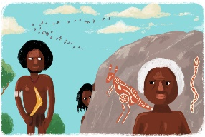 | 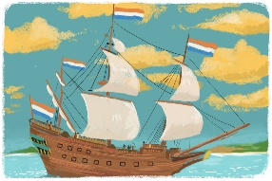 | 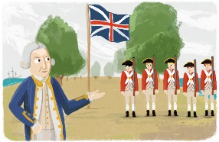 | 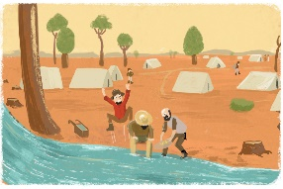

1 The first people of Australia are called the Aboriginal people.
Prvi ljudi u Australiji se zovu Aboridžini.
2 They came to Australia 50,000 years ago.
Došli su u Australiju prije 50000 godina.
3 The first white people who came to Australia on their ships were
Dutch explorers in 1606.
Prvi bijeli ljudi koji su došli u Australiju na svojim brodovima su bili
nizozemski istraživači 1606.
4 The first white settlers were the soldiers and prisoners from Great Britain.
Prvi bijeli doseljenici su bili vojnici i zatvorenici iz Velike Britanije.
5 The British began to settle there in 1788.
Britanci su se tamo počeli naseljavati 1788. godine.
6 When gold was discovered in Australia in 1851, thousands of new
immigrants came there.
Kad su u Australiji otkrili zlato 1851., tisuće novih useljenika je došlo
tamo.
7 Finally, six Australian colonies united and became the
Commonwealth of Australia in 1901.
Konačno, 1901. Šest se australijskih kolonija ujedinilo i postalo
‘Commonwealth of Australia’.

a) Copy the past simple form of the verbs on the lines.
4
Prepiši past simple glagola na crte.
Infinitive |  | Past Simple
come | doći | came | ________________
begin | početi | began | ________________
become | postati | became | ________________
be | biti | was / were | ________________

b) Read the sentences and circle the correct word.
Pročitaj rečenice i zaokruži točnu riječ.

1 The Aboriginal people be / were the first people of Australia.
2 Dutch explorers come / came to Australia in 1606.
3 The British begin / began to settle Australia in 1788.
4 Six Australian colonies become / became one country in 1901.
c) Copy the correct sentences and tell your teacher what you remember about
the past of Australia.
Prepiši točne rečenice i reci učiteljici čega se sjećaš o prošlosti Australije.

1 _____________________________________________________.
2 _____________________________________________________.
3 _____________________________________________________.
4 _____________________________________________________.

