PARTED BUT UNITED
2B
1
a) Match and read.
Poveži i pročitaj.

1 regular school | dopisna škola
2 primary school | internat
3 boarding school  1 | škola kod kuće
4 correspondence school | redovna škola
5 home education | osnovna škola

b) Translate the words into English.
Prevedi riječi na engleski jezik.

1 osnovna škola | _______________________
2 redovna škola | _______________________
3 dopisna škola | _______________________
4 internat | _______________________
5 škola kod kuće | _______________________

c) Answer the question.
Odgovori na pitanje.
What kind of school do you go to?
Koju vrstu škole ti pohađaš?
I _____________________________________________________

a) Look at the pictures. Read what Maya writes about the School of the Air.
2
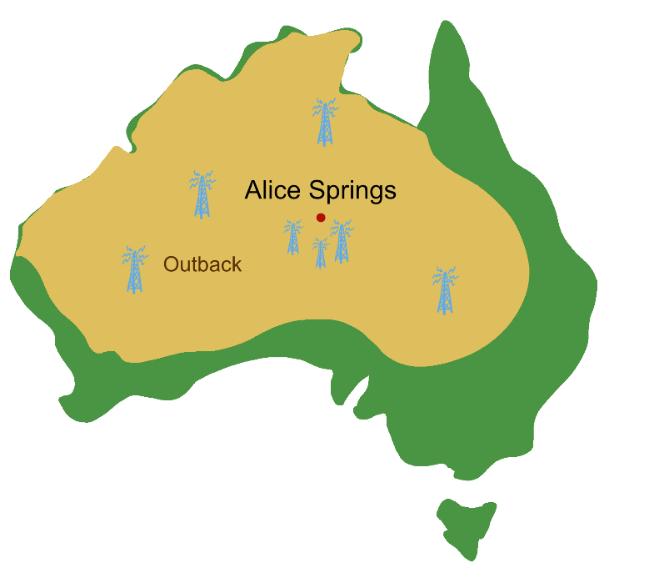
Pogledaj slike. Pročitaj što Maya piše o Radio školi.

I lived in Alice Springs.
Živjela sam u Alice Springsu.
I often visited my cousins.
Često sam posjećivala svoje rođake.
They live on a cattle station in the Outback.
Oni žive na stočnoj farmi u unutrašnjosti Australije.
They don’t go to a regular school. It’s far away.
Oni ne idu u redovitu školu. Daleko je.
Their school is called ‘School of the Air’.
Njihova škola se zove ‘Radio škola’.
The Alice Springs School of the Air started in 1951.
Radio škola iz Alice Springsa je započela s radom 1951. godine.
Children listened to the lessons via radio, at their homes.
Djeca su slušala predavanja preko radija kod kuće.
They sent their work to teachers by post.
Oni su slali svoje radove učiteljima poštom.
Today, the school doesn’t use radio or post.
Danas škola ne koristi radio ili poštu.
They use modern technology.
Koriste modernu tehnologiju.

b) Read the text again. Pay attention to the words in red. Then match the words
in English to the words in Croatian.
Ponovo pročitaj tekst. Obrati pozornost na crvene riječi. Zatim poveži riječi na
engleskom jeziku s riječima na hrvatskom jeziku.

1 technology | __ | unutrašnjost Australije
2 post | __ | stočna farma
3 cattle station | __  1 | tehnologija
4 far away | __ | pošta
5 School of the Air | __ | daleko
6 Outback | __ | Radio škola

c) Are these sentences true? Circle the right answer.
Jesu li ove rečenice točne? Zaokruži točan odgovor.

1 Maya lived in Alice Springs.  Maya je živjela u Alice Springsu. | YES | NO
2 Maya’s cousins live on a cattle farm in the Outback.  Mayini rođaci žive na stočnoj farmi u unutrašnjosti Australije. | YES | NO
3 It is far away from Alice Springs.  To je daleko od Alice Springsa. | YES | NO
4 They don’t go to a regular school.  Oni ne idu u redovnu školu. | YES | NO
5 They go to School of the Air.  Oni idu u Radio školu. | YES | NO
d) Write the missing words. Exercise 2 a) can help you.
Napiši riječi koje nedostaju. Zadatak 2. a) može ti pomoći.
1951
1 The Alice Springs school of the Air started in ________________.
2 Children were at home and listened to the lessons via _______________.
3 They sent their work to teachers by ____________________.
4 Today, they don't use ____________________ and post.
5 They use modern ____________________.
Read the sentences about the School of the Air and tick the negative sentences.
3
Pročitaj rečenice o Radio školi i označi kvačicom niječne rečenice.

WHEN I WAS A PUPIL
KAD SAM BIO ĐAK
My teacher didn’t have a blackboard.  Moja učiteljica nije imala ploču. | ___
She had a microphone.  Imala je mikrofon. | ___
She talked and talked.  Pričala je i pričala. | ___
She didn’t see her pupils.  Ona nije vidjela učenike. | ___
I didn’t sit in a classroom.  Nisam sjedio u učionici. | ___
I listened to the radio.  Slušao sam radio. | ___
THE PAST SIMPLE: NEGATIVE FORM

My…
GRAMMAR!
PROŠLO VRIJEME: NIJEČNI OBLIK
LOOK AND READ!
POGLEDAJ I PROČITAJ!
Positive sentences | Negative sentences
Regular verbs
Pravilni glagoli
I listened to my teacher.  Slušao / Slušala sam učiteljicu. | I didn’t listen to my teacher.  Nisam slušao / slušala učiteljicu.
My teacher used a microphone.  Učiteljica je koristila mikrofon. | She didn’t use a chalk.  Nije koristila kredu.
Irregular verbs
Nepravilni glagoli
My teacher had a radio.  Učiteljica je imala radio. | She didn’t have a blackboard.  Ona nije imala školsku ploču.
She saw her friends.  Ona je vidjela svoje prijatelje. | She didn’t see her pupils.  Ona nije vidjela svoje učenike.
4
a) Make negative form of these verbs.
Napiši negativni oblik ovih glagola.

regular verbs  didn’t watch |  | irregular verbs
1 I watched | I ________________  didn’t | 1 I went | I ________________  take  didn’t go
2 she played | she ______________  talk | 2 he took | he _______________
3 they talked | they______________ | 3 we met | we _______________  didn’t
4 I lived | I _________________ | 4 she had | she ______________
5 he visited | he _______________ | 5 they left | they ______________
b) Maya visited her cousins in the Outback last summer. Look at the pictures and
read the sentences. Are the sentences true? Write negative sentences.
Maya je posjetila svoje rođake u unutrašnjosti Australije prošlo ljeto. Pogledaj slike i
pročitaj rečenice. Jesu li rečenice točne? Napiši negativne rečenice.

1 Maya saw snakes behind the house.  Maya je vidjela zmije iza kuće.  _____________________________________  Maya didn’t see snakes behind the house. | 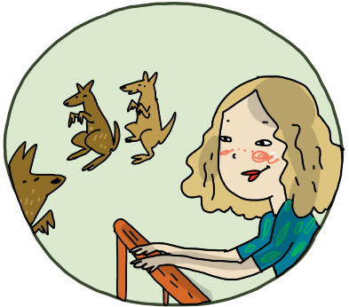
2 She took a lot of photos.
Ona je snimila mnogo fotografija.
_____________________________________
_____________________________________
3 She and her cousins went whale watching.  Ona i njeni rođaci išli su promatrati kitove. _____________________________________  _____________________________________ | 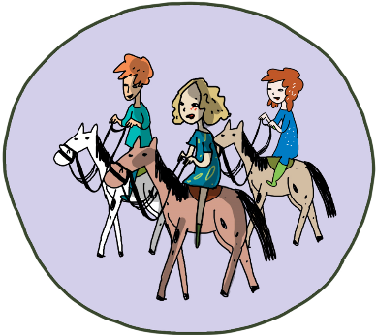
4 They played video games.  Oni su igrali video igrice. _____________________________________  _____________________________________ | 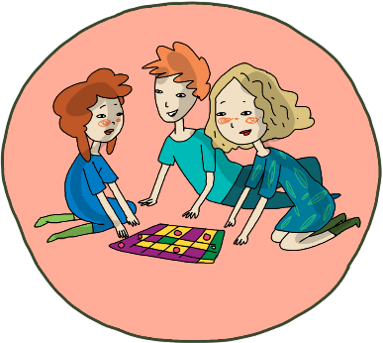

Write five sentences about what you didn’t do last week.
5
Napiši pet rečenica o tome što nisi radio / radila prošli tjedan.
I didn’t play videogames.
1 ______________________________________________.
2 ______________________________________________.
3 ______________________________________________.
4 ______________________________________________.
5 ______________________________________________.

