1
MAKING THE MODERN WORLD
3AA
a) Read the words. Translate the words discovery and invention into Croatian.
Use the words from the box.
Pročitaj riječi. Prevedi riječi discovery i invention na hrvatski jezik. Upotrijebi riječi iz
kućice.
izum otkriće
otkriti
1 discover | __________________________
2 discovery | __________________________
3 invent | __________________________  izumiti
4 invention | __________________________

b) Complete the sentences. Use the words invention and discovery.
Nadopuni rečenice. Koristi riječi izum i otkriće.

1 When someone finds something that was there but no one knew about it,
Kad netko nađe nešto što postoji ali nitko nije znao o tome,
it is a _____________________.
to je _____________________.
2 When someone makes something new that wasn’t there before,
Kad netko napravi nešto novo što prije nije postojalo,
it's an _____________________.
to je _____________________.

c) Copy the words in English on the empty lines.
Prepiši engleske riječi na praznecrte.

1 electricity | __________________ | električna struja
2 telephone | __________________ | telefon
3 computer | __________________ | računalo
4 planet | __________________ | planet
5 fire | __________________ | vatra
6 gravity | __________________ | gravitacija

d) Circle the correct word. Exercise 1 c) can help you. Read the sentences to
your teacher.
Zaokruži točnu riječ. Zadatak 1. c) može ti pomoći. Pročitaj rečenice svojoj učiteljici.

1 Gravity is  Gravitacija je | a) a discovery.  otkriće. | b) an invention.  izum.
2 Electricity is  Električna struja je | a) a discovery.  otkriće. | b) an invention.  izum.
3 The telephone is  Telefon je | a) a discovery.  otkriće. | b) an invention.  izum.
4 Fire is  Vatra je | a) a discovery.  otkriće. | b) an invention.  izum.
5 The computer is  Računalo je | a) a discovery.  otkriće. | b) an invention.  izum.
6 New planets are  Novi planeti su | a) a discovery.  otkriće. | b) an invention.  izum.

a) Look at the pictures. Write the name under each invention.
2
Pogledaj slike. Napiši naziv ispod svakog izuma.

1 wheel | kotač
2 printing press | tiskarski stroj
3 compass | kompas

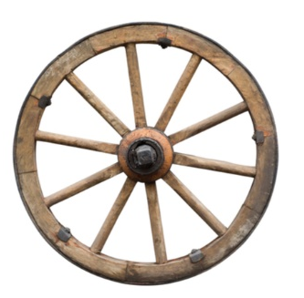 | 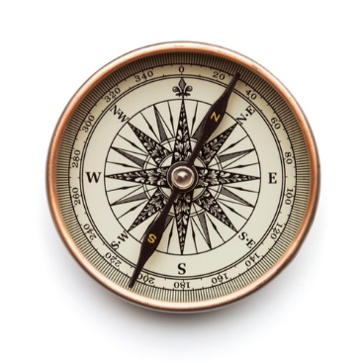 | 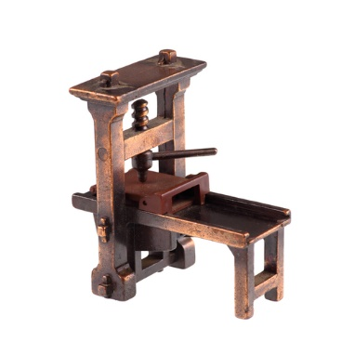
1_________________ | 2_________________ | 3_________________

b) Read with your friend about three important inventions. What is each text
about? Write the correct heading on the lines. Exercise 2 a) can help you.
Pročitaj s prijateljicom / prijateljem o tri važna izuma. O čemu se radi u svakom
tekstu? Napiši točan naslov na crte. Zadatak 2. a) može ti pomoći.
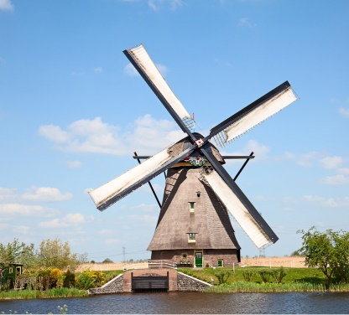
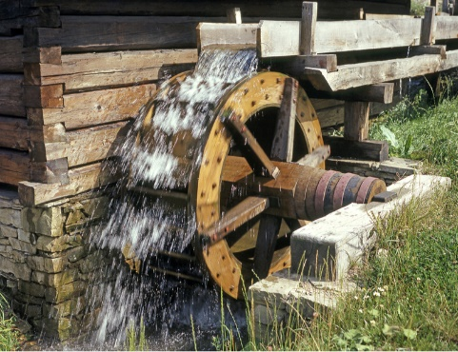
1 ______________________

People who lived in the Bronze Age invented the first wheel.
Ljudi koji su živjeli u Brončanom dobu su izumili prvi kotač.
Someone invented it in Mezopotamia.
Netko ga je izumio u Mezopotamiji.
After that, people made carts, chariots and other vehicles.
Nakon toga ljudi su napravili kola na dva kotača, bojna kola i druga vozila.
Wheels are also used in windmills and watermills.
Kotači se također koriste na vjetrenjačama i mlinovima.

2 ______________________

The invention of compass is very important for sea travel.
Izum kompasa je jako važan za putovanje morem.
It is a device which shows direction.
To je uređaj koji pokazuje smjer.
It has a small needle that always points north.
Ima malu iglu koja uvijek pokazuje na sjever.
The Chinese started using the compass in the 2nd century BC.
Kinezi su počeli koristiti kompas u 2. stoljeću prije Krista.
It came to Europe between the 12th and 13th centuries.
Došao je u Europu između 12. i 13. stoljeća.
Sailors sailed across the oceans and discovered new lands.
Mornari su plovili preko oceana i otkrili nove zemlje.

3 ______________________

Johannes Gutenberg invented the modern printing press
Johannes Gutenberg je izmislio moderni tiskarski stroj
in the mid-15th century.
sredinom 15. stoljeća.
Gutenberg’s method of printing was cheap and quick.
Gutenbergova metoda tiskanja je bila jeftina i brza.
They could print books in large quantities.
Mogli su tiskati knjige u velikim količinama.
Lots of people could read and get new information and knowledge.
Mnogo je ljudi moglo čitati i dobiti nove informacije i znanja.

c) Read the text again and answer the questions.
Pročitaj tekstove ponovo i odgovori na pitanja.
Who invented...
Tko je izumio…
1 the wheel? | ______________________________________
2 the compass? | ______________________________________
3 the printing press? | ______________________________________

d) What is it – wheels, compass or printing press? Read the questions
and answer them.
Što je to – kotači, kompas ili tiskarski stroj? Pročitaj pitanja i odgovori na njih.

1 What helped sailors to discover new lands?
Što je pomoglo mornarima otkriti nove zemlje?
_____________________________________________________
2 What is used to make vehicles?
Što se koristi za izradu vozila?

_____________________________________________________
3 What is used in windmills and watermills?
Što se koristi na vjetrenjačama i mlinovima?

_____________________________________________________
4 What is used to make books?
Što se koristi za izradu knjiga?

_____________________________________________________
5 What has a needle that always points north?
Što ima iglu koja uvijek pokazuje sjever?

_____________________________________________________
6 What helped people get new information quickly?
Što je pomoglo ljudima da brzo dobiju nove informacije?

_____________________________________________________
ORDINAL NUMBERS

My…
GRAMMAR!
REDNI BROJEVI
LOOK AND READ!
1st | first | 11th | eleventh
2nd | second | 12th | twelfth
3rd | third | 13th | thirteenth
4th | fourth | 14th | fourteenth
5th | fifth | 15th | fifteenth
6th | sixth | 16th | sixteenth
7th | seventh | 17th | seventeenth
8th | eighth | 18th | eighteenth
9th | ninth | 19th | nineteenth
10th | tenth | 20th | twentieth

U hrvatskom jeziku iza rednog broja pišemo točku. (1.)
U engleskom jeziku pišemo slova iza broja. (1st)
Slova koja pišemo iza broja su zadnja dva slova tog rednog broja.
first – 1st
second – 2nd
third – 3rd
fourth – 4th
fifth – 5th
Redni brojevi first, second i third su nepravilnog oblika i zbog toga se razlikuju od ostalih rednih brojeva koji završavaju na –th.

a) Read the texts again and answer the questions.
3
Ponovno pročitaj tekstove i odgovori na pitanja.

1 When was the wheel invented?
Kada je izumljen kotač?
It was invented in _______________________________________.
2 When was the compass invented?
Kada je izumljen kompas?
It ___________________________________________________.
3 When was the printing press invented?
Kada je izumljen tiskarski stroj?
____________________________________________________ .

b) Tell your teacher which of these inventions seems most interesting to you.
Explain why.
Reci svojoj učiteljici koji od ovih izuma ti izgleda najzanimljiviji. Objasni zašto.

