1
2BA
GET BETTER SOON!
Read the sentences. Circle the correct words.
Pročitaj rečenice. Zaokruži točne riječi.
1 Bob is healthy / sick.
On je zdrav / bolestan.
2 He has got the flu.
Ima gripu.
3 He has to see a doctor / teacher.
Mora posjetiti doktora / učitelja.
2
a) Read the sentences to your teacher. Point to the pictures and say
what they mean.
Pročitaj rečenice učiteljici. Pokaži slike i reci što znače.

1 I have a cold. |  | Prehlađen sam.
2 I have a fever. | 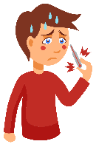 | Imam groznicu.
3 I have a runny nose. |  | Curi mi nos.
4 I have a headache. |  | Boli me glava.
5 I have a sore throat. | 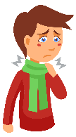 | Boli me grlo.
6 I have a cough. |  | Kašljem.

b) Match the sentences. Exercise 1 a) can help you.
Poveži rečenice. Zadatak 1. a) ti može pomoći.

1 I have a fever. | Prehlađen sam.
2 I have a runny nose. | Boli me grlo.
3 I have a headache. | Kašljem.
4 I have a cold. | Boli me glava.
5 I have a cough. | Curi mi nos.
6 I have the flu.  1 | Imam groznicu.
7 I have a sore throat. | Imam gripu.

c) Translate the sentences into English.
Prevedi rečenice na engleski jezik.

1 Curi mi nos. | __________________________________
2 Boli me grlo. | __________________________________
3 Kašljem. | __________________________________
4 Boli me glava. | __________________________________
5 Imam gripu. | __________________________________
6 Prehlađen sam. | __________________________________
7 Imam groznicu. | __________________________________

a) Read the sentences. Translate the missing parts into Croatian.
3
Pročitaj rečenice. Prevedi dijelove koji nedostaju na hrvatski jezik.
The children are not well. They can’t go to school.
Djeca nisu dobro. Ne mogu ići u školu.
Zoe has a bad cough and fever.
Zoe mnogo ________________________ i ima ________________________.
Thierry has a toothache.
Thierryja boli zub.
Aaron has a headache and a runny nose.
Aron ima _______________________________________________________.
Ben has a sore throat.
Bena __________________________________________________________.

b) Read the text again. Write the children’s names under their pictures.
Ponovno pročitaj tekst. Napiši imena djece ispod njihovih slika.
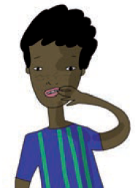 | 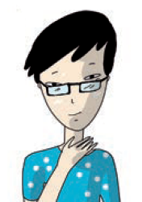 | 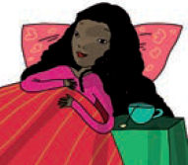 | 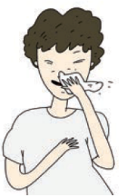
Thierry  _____________ | _____________ | _____________ | _____________

c) Make questions about the children. Pay attention to the answers.
Postavi pitanja o djeci. Obrati pažnju na odgovore.
a headache and a runny nose?
1 Who has _____________________________________? Aaron.
2 Who has a ________________ and ________________? Zoe.
3 Who _________________________________________? Ben.
4 Who _________________________________________? Thierry.
4
What do you do when you are ill? Complete the sentences with the words
from the box.
Što radiš kad si bolestan / bolesna? Dopuni rečenice riječima iz kućice.

doctor medicine vitamin C tea bed dentist

1 I take some _______________.  Popijem lijek. | 4 I go to see a _______________.  Idem kod zubara.
2 I drink _______________.  Pijem čaj. | 5 I take _______________.  Popijem vitamin C.
3 I go to see a _______________.  Idem kod liječnika. | 6 I stay in _______________.  Ostanem u krevetu.

b) Match the sentences from the Exercise 4 a) with the pictures. Say what they
mean in English.
Poveži rečenice iz zadatka 4. a) sa slikama. Kaži što one znače na engleskom jeziku.

 | 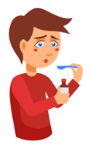 | 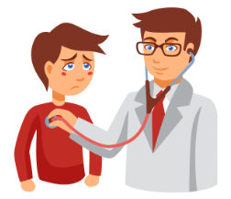
1 | 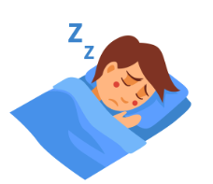 | 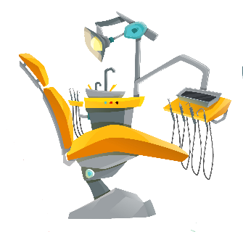

GIVING ADVICE
DAVANJE SAVJETA
You should see a doctor.  Ti bi trebao / trebala ići k liječniku. | You shouldn’t go to school.  Ne bi trebao / trebala ići u školu.
4
a) Read the sentences. Circle should or shouldn’t.
Pročitaj rečenice. Zaokruži should (trebao bi) ili shouldn’t (ne bi trebao).

Bob has the flu. What should he do?
Bob ima gripu. Što bi trebao raditi?
1 He should / shouldn’t drink a lot of tea.
Trebao bi / ne bi trebao piti mnogo čaja.
2 He should / shouldn’t go out.
Trebao bi / ne bi trebao ići vani.
3 He should / shouldn’t stay in bed.
Trebao bi / ne bi trebao ostati u krevetu.
4 He should / shouldn’t play with other children.
Trebao bi se / ne bi se trebao igrati s drugom djecom.
5 He should / shouldn’t do sport.
Trebao bi se / ne bi se trebao baviti sportom.
6 He should / shouldn’t take an aspirin.
Trebao bi / ne bi trebao popiti aspirin.
7 He should / shouldn’t eat fresh fruit.
Trebao bi / ne bi trebao jesti svježe voće.
b) What should or shouldn’t you do when you have a cold? Exercises 4 and 5
can help you. Report to your teacher.
Što bi ti trebao / trebala ili ne bi trebao / trebala raditi kad si prehlađen / prehlađena?
Zadatci 4. i 5. mogu ti pomoći. Reci učiteljici.
1 I should __________________________________________________.
2 I shouldn’t ________________________________________________.

