3BA
EAT SMART
1
Read the English words with your friend. Check what they mean in Croatian. Tick (✓) those that you like most.
Pročitaj riječi na engleskom jeziku sa svojim prijateljem / prijateljicom. Provjeri što te riječi znače na hrvatskom jeziku. Stavi kvačicu (✓) pokraj onih koje najviše voliš.
1 protein | proteini | ______
2 grains | žitarice | ______
3 dairy | mliječni proizvodi | ______
4 fruit | voće | ______
5 vegetables | povrće | ______
2
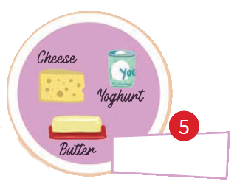
a) Look at the picture and write the correct words from Exercise 1 in the boxes.
Pogledaj sliku i napiši točne riječi iz zadatka 1. u kućice.

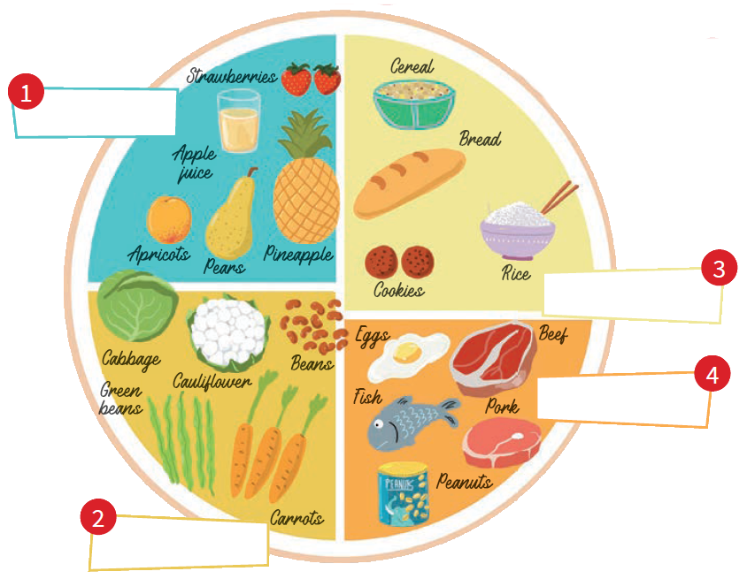

b) Copy the words in Croatian next to the words in English.
Prepiši riječi na hrvatskom jeziku pokraj riječi na engleskom jeziku.

sir kupus marelica jaja maslac
kruh kruška mrkve riba keksi

1 apricot | _____________________________________
2 pear | _____________________________________  jagode
3 strawberries | _____________________________________
4 butter | _____________________________________
5 cheese | _____________________________________  jogurt
6 yoghurt | _____________________________________
7 bread | _____________________________________
8 cookies | _____________________________________  riža
9 rice | _____________________________________
10 carrots | _____________________________________
11 cabbage | _____________________________________  grah
12 beans | _____________________________________
13 fish | _____________________________________
14 eggs | _____________________________________  govedina
15 beef | _____________________________________

c) Write the missing letters. Read the words to your teacher.
Napiši slova koja nedostaju. Pročitaj riječi učiteljici.
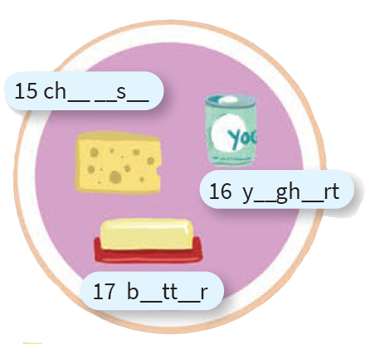
15 ch__ __ s __
16 y__ gh __ rt
17 b__ tt __ r

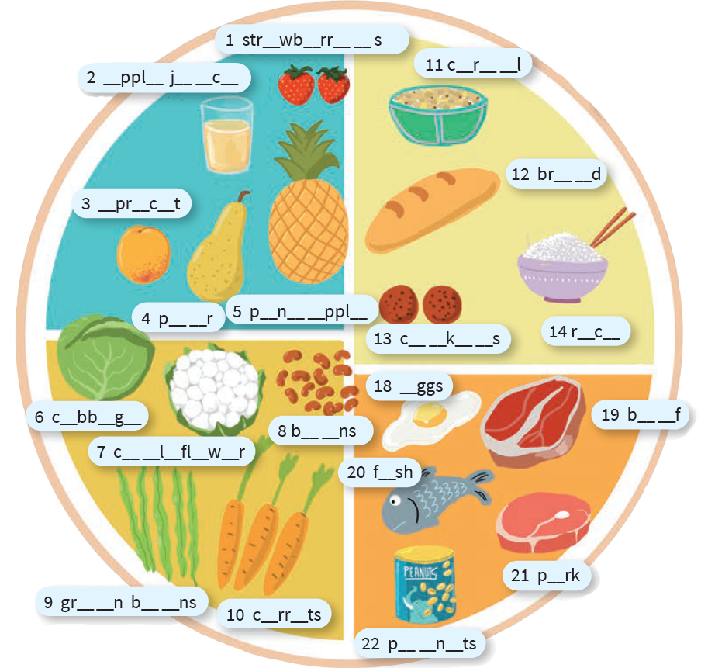
5 p__n__ __ppl__
2 apple juice
1 str__wb__rr__ __s
3 __ pr __ c __ t
4 p __ __ r
6 c__bb__ g __
7 cauliflower
8 b__ __ ns
9 green beans
10 c__ rr__ ts
11 cereals
12 br__ __ d
13 c__ __ k__ __ s
14 r__ c __
18 __ ggs
19 b__ __ f
20 f__ sh
21 pork
22 peanuts

a) Are the sentences correct? Circle True or False.
3
Jesu li rečenice točne? Zaokruži True (točno) ili False (netočno).

1 Healthy food is always tasty.  Zdrava hrana je uvijek ukusna. | True False
2 Healthy food is sometimes tasty.  Zdrava hrana je ponekad ukusna. | True False
3 You should eat fruit and vegetables every day.  Trebao bi jesti voće i povrće svaki dan. | True False
4 Fish and meat are good source of protein.  Riba i meso su dobar izvor proteina. | True False
5 Cookies are never healthy.  Keksi nikad nisu zdravi. | True False

b) Look at the picture again. Write which food you often, sometimes, rarely
or never eat.
Ponovno pogledaj sliku. Napiši koju hranu jedeš često, ponekad, rijetko ili koju
hranu nikad ne jedeš.
1 I often eat _____________________________________________.
2 I rarely _______________________________________________.
3 I ____________________________________________________.
4 I ____________________________________________________.

c) Translate the sentences from Exercise 2 a) into Croatian.
Prevedi rečenice iz zadatka 2. a) na hrvatski jezik.

1 Ja često jedem __________________________________________.
2 _______________________________________________________.
3 _______________________________________________________.
4 _______________________________________________________.
a) Match.
4
Poveži.
1 favourite |  | kisel
2 tasty |  | slan
3 salty | 1 | sladak
4 sweet |  | omiljen
5 sour |  | zdrav
6 healthy |  | ukusan

b) Which of the foods from Exercise 2 are...
Koja hrana iz zadatka 2. je...
1 tasty?  ukusna? | __________________________________________
2 salty?  slana? | __________________________________________
3 healthy?  zdrava? | __________________________________________
4 sweet?  slatka? | __________________________________________
5 sour?  kisela? | __________________________________________
6 your favourite?  tvoja omiljena? | __________________________________________

5
a) Read what one mum says about her family’s eating habits. Circle the correct
verb form.
Pročitaj što jedna mama kaže o prehrambenim navikama njezine obitelji. Zaokruži
točan glagolski oblik.

1 I cook / am cooking every day.
2 We usually eat / are eating healthy food.
3 We always eat / are eating fresh fruit and vegetables.
4 Now we are / are being at home.
5 I cook / am cooking fish, cabbage and potatoes.
6 My son helps / is helping me.
7 He likes / is liking fish and vegetables very much.

b) Translate the sentences from Exercise 5 a) into Croatian.
Prevedi rečenice iz zadatka 5. a) na hrvatski jezik.

1 ________________________________________________________
2 ________________________________________________________
3 ________________________________________________________
4 ________________________________________________________
5 ________________________________________________________
6 ________________________________________________________
7 ________________________________________________________

