1
READY, SET, GO!

a) Look at the map of the world. Write the cardinal points of the compass.
Use the words from the box.
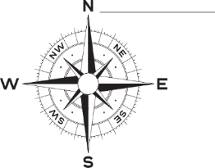
Pogledaj kartu svijeta. Napiši glavne strane svijeta. Upotrijebi riječi iz kućice.

North South East West

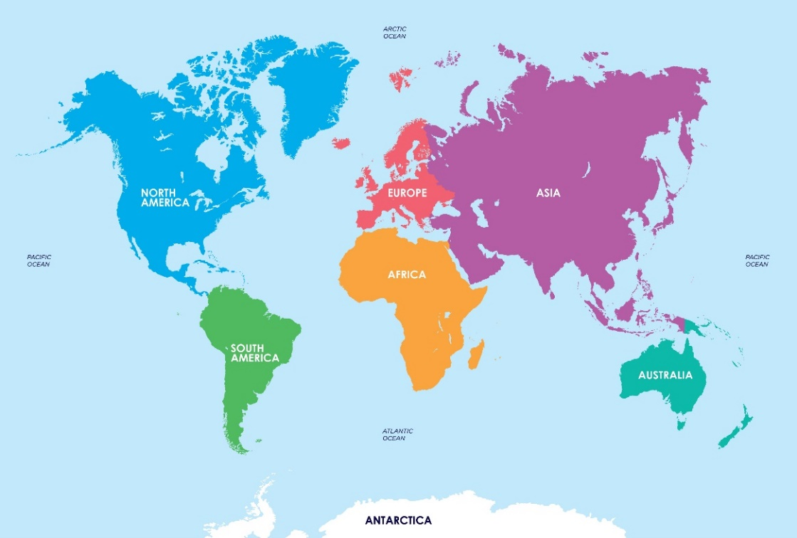

b) Look at the map and find Australia. Circle the correct answer.
Pogledaj kartu i pronađi Australiju. Zaokruži točan odgovor.

1 Where is Australia?
Gdje se nalazi Australija?

a) It is in the North. | b) It is in the South.
2 Is Australia the largest continent in the world?
Je li Australija najveći kontinent na svijetu?

a) Yes, it is. | b) No, it isn't.
a) Look at the map of Australia. Circle the correct answer. Read the sentences
to your teacher. Explain what they mean.
2
Pogledaj kartu Australije. Zaokruži točan odgovor. Pročitaj rečenice učiteljici.
Objasni što znače.
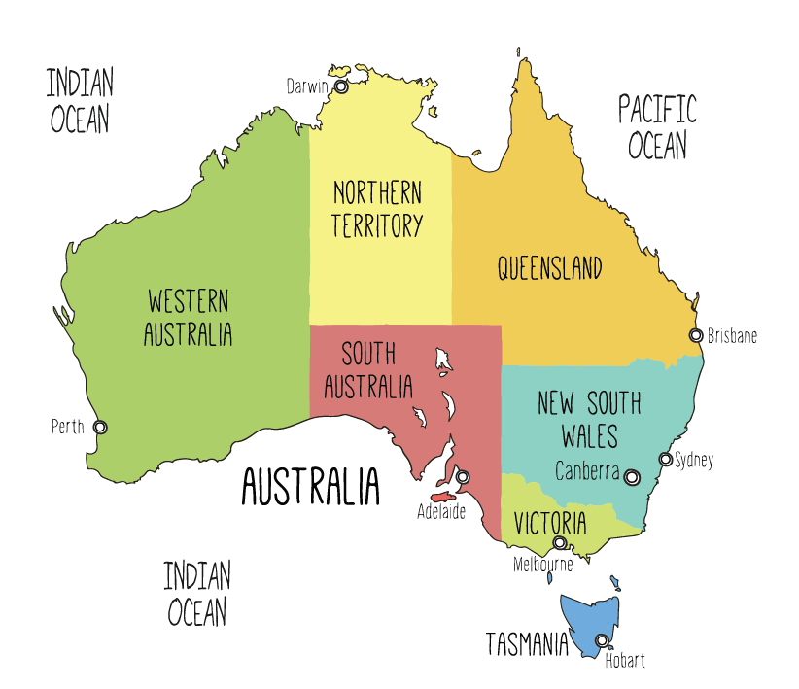
1 There are a) 2 oceans.
b) 3 oceans.
2 Their names are a) the Indian and the Atlantic Ocean.
b) the Indian and the Pacific Ocean.
3 Sidney, Melbourne and Canberra are big a) cities.
b) countries.

b) Copy the correct sentences.
Prepiši točne rečenice.
__________________________________________________________
__________________________________________________________
__________________________________________________________
__________________________________________________________
a) Read the text.
3
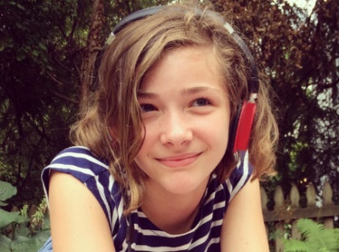
Pročitaj tekst.
This is Maya.
Ovo je Maya.
She lives in Melbourne, Australia.
Ona živi u Melbourneu, Australiji.
Australia is a continent and a country.
Australija je kontinent i država.
It is the sixth largest country in the world.
To je šesta najveća država na svijetu.
It lies between the Pacific and the Indian Ocean.
Nalazi se između Tihog i Indijskog oceana.
The capital city is Canberra.
Glavni grad je Canberra.
Most people in Australia speak English.
Većina ljudi u Australiji govori engleski.
The native Australians are Aborigines.
Prvi stanovnici Australije su Aboridžini.
Australia was a British colony in the past.
Australija je bila britanska kolonija u prošlosti.
That’s why the British flag is a part of the Australian flag.
Zbog toga je britanska zastava dio australske zastave.
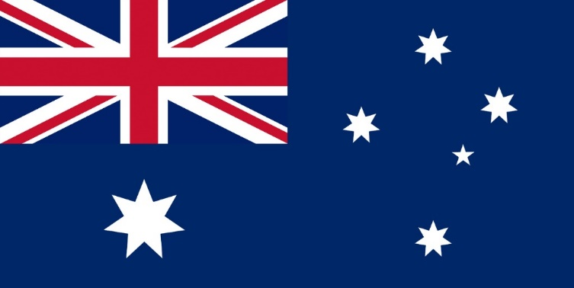
b) Read the text again and answer the questions. Use the words from the box.
Ponovo pročitaj tekst i odgovori na pitanja. Upotrijebi riječi iz kućice.

Aborigines country English Melbourne continent Canberra

1 Where does Maya live?
Gdje Maya živi?
Maya lives in ______________________________.
2 What is Australia?
Što je Australija?
Australia is a __________________ and a _____________________.
3 What is the capital city of Australia?
Koji je glavni grad Australije?
The capital city of Australia is _________________________________.
4 What language do most people in Australia speak?
Koji jezik većina ljudi u Australiji govori?
Most people in Australia speak _______________________________.
5 Who are the native Australians?
Tko su prvi stanovnici Australije?
___________________ are the native Australians.

c) Match.
Poveži.
1 This is the British flag. | 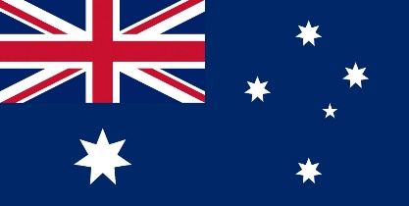
2 This is the Australian flag.
a) Some animals live only in Australia. Match the pictures and the names of
animals.
4
Neke životinje žive samo u Australiji. Poveži slike i imena životinja.
1 koala | 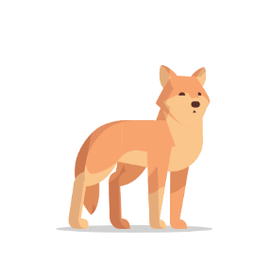
2 dingo | 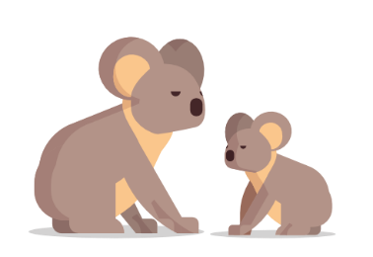  1
3 Tasmanian devil | 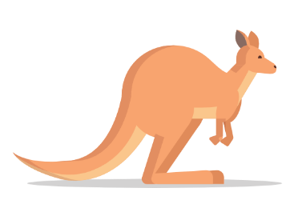
4 kangaroo | 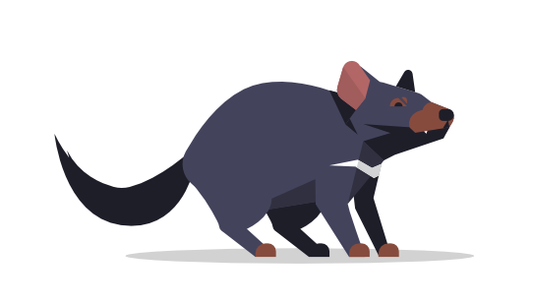

b) Draw your favourite Australian animal. What animal is it?
Nacrtaj svoju omiljenu australsku životinju. Koja je to životinja?

