A SURPRISE FOR GRANDMA
2BA
1

a) Do you like sweet food? Read the sentences and circle all words in bold that are
true for you.
Voliš li slatku hranu? Pročitaj rečenice i zaokruži sve podebljane riječi koje se odnose na
tebe.

1 My favourite dessert is some fruit / a fruit cake / an apple pie / biscuits.
Moj omiljeni desert je voće / voćni kolač / pita od jabuka / keksi.
2 I like it because it is very sweet / not too sweet.
Volim ga jer je jako sladak / nije presladak.
3 I can make a pudding / take an apple and peel it.
Znam napraviti puding / uzeti jabuku i oguliti je.
4 My mum / dad always makes desserts.
Moja mama / tata uvijek radi deserte.

b) Copy the sentences that are true for you.
Prepiši rečenice koje su istinite za tebe.
1 _______________________________________________.
2 _______________________________________________.
3 _______________________________________________.
4 _______________________________________________.

c) Translate the sentences into Croatian.
Prevedi rečenice na hrvatski jezik.
1 _______________________________________________.
2 _______________________________________________.
3 _______________________________________________.
4 _______________________________________________.

a) Match the halves of the sentences.
2
Poveži polovice rečenica.

1 a teaspoon |  | of tea
2 a tablespoon |  | of salt
3 a cup |  | of milk
4 a pinch | 1 | of coffee
5 a glass |  | of sugar
b) Translate the words into English.
Prevedi riječi na engleski jezik.

1 žlica šećera | _______________________
2 šalica čaja | _______________________
3 čaša mlijeka | _______________________
4 čajna žličica kave | _______________________
5 prstohvat soli | _______________________

c) Label the pictures. Exercise 2 b) can help you.
Označi slike. Zadatak 2. b) može ti pomoći.
 | 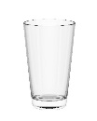 | 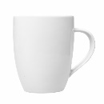
1 ________________ | 2 ________________ | 3 ________________
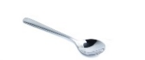 | 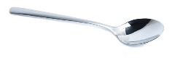
4 ________________ | 5 ________________
a) Raj’s mum is making a fruit salad. Look at the pictures and complete the
measurements with the words in the box.
3
Rajeva mama radi voćnu salatu. Pogledaj slike i nadopuni mjere riječima iz kućice.

one glass two teaspoons a big cup
two four three

1 ______________________ of orange juice | 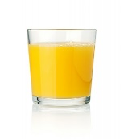
2 ______________________ apples | 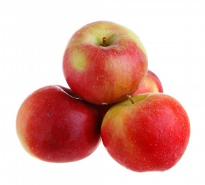
3 ______________________ bananas | 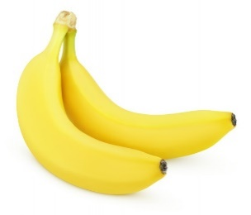
4 ______________________ of brown sugar

5 ______________________ of blueberries

6 ______________________ kiwis | 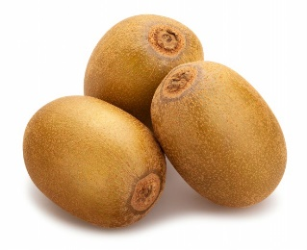

b) Raj is helping his mum. Read Raj’s questions and complete his mum’s answers.
Raj pomaže mami. Pročitaj Rajeva pitanja i nadopuni mamine odgovore.

Raj: | How much orange juice do you need?  Koliko narančinog soka trebaš?
Mum: | One ___________________.
Raj: | How much brown sugar do you need?  Koliko smeđeg šećera trebaš?
Mum: | Two ___________________ of brown sugar.
Raj: | How many bananas do you need?  Koliko banana trebaš?
Mum: | Two ___________________.
Raj: | How many blueberries do you need?  Koliko borovnica trebaš?
Mum: | A big cup of ___________________.
Raj: | How many apples do you need?  Koliko jabuka trebaš?
Mum: | Four ___________________.
Raj: | How many kiwis do you need?  Koliko kivija trebaš?
Mum: | Three ___________________.

HOW MUCH? or HOW MANY?

My…
GRAMMAR!

LOOK AND READ!
POGLEDAJ I PROČITAJ!
Izraz how many koristimo s brojivim imenicama (imenicama koje možemo prebrojati).
How many apples do you need?
I need four apples.
Izraz how much koristimo s nebrojivim imenicama (imenicama koje ne možemo
prebrojati).
How much water do you need?
I need some water.

4
a) Look at the pictures. Label each group with correct question words: How much or
How many.
Pogledaj slike. Označi svaku grupu s točnim upitnim riječima: How much ili How many.
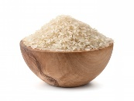  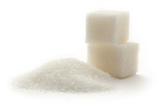  water  sugar  rice  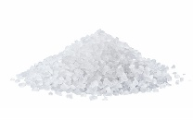  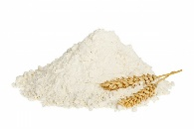  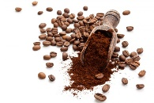  flour  salt  coffee | 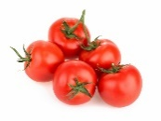  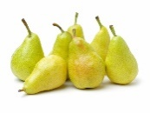  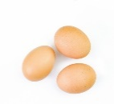  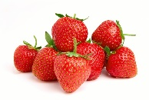  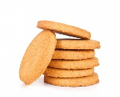  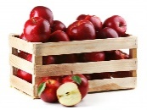  pears  strawberries  biscuits  apples  eggs  tomatoes

b) Make questions. Use How much or How many. Exercise 4 a) can help you.
Postavi pitanja. Upotrijebi How much ili How many. Zadatak 4. a) može ti pomoći.

1 ___________________ pears did you eat last week?
Koliko krušaka si pojeo prošlog tjedna?
2 ___________________ sugar do you put in your tea?
Koliko šećera stavljaš u čaj?
3 ___________________ coffee does your mum drink a day?
Koliko kave tvoja mama pije dnevno?
4 ___________________ eggs does your mum buy every week?
Koliko jaja tvoja mama kupuje svaki tjedan?
5 ___________________ water do you drink a day?
Koliko vode piješ na dan?
6 ___________________ tomatoes can you eat in two minutes?
Koliko rajčica možeš pojesti u dvije minute?

c) Ask your friend the questions from Exercise 4 a). Write his / her answers.
Pitaj prijatelja pitanja iz zadatka 4. a). Napiši njegove / njezine odgovore.

1 I ate ___________________________________________________.
2 I put ______________________________________ sugar in my tea.
3 My mum drinks __________________________________________.
4 She buys_______________________________________________.
5 I drink _________________________________________________.
6 I can eat _______________________________________________.

Listen what Raj wants to do. Read the sentences and circle True or False.
5
Poslušaj što Raj želi napraviti. Zaokruži True (točno) ili False (netočno).
Raj is talking to his mum.
He wants to make a birthday cake for his grandma’s birthday.
He wants to make grandma’s favourite dessert.
It’s a rice pudding.
Grandma used to cook it when Raj was little.
.

1 Raj is talking to his mum. | True | False
2 It is Raj’s birthday. | True | False
3 It is grandma’s birthday. | True | False
4 Raj wants to make his grandma’s favourite dessert. | True | False
5 It is a rice pudding. | True | False

