Sand and Stone Story

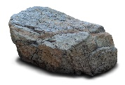 stone
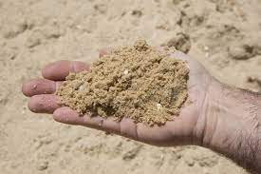 sand
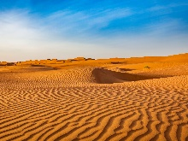 desert
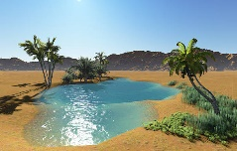 oasis
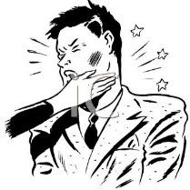 slap somebody
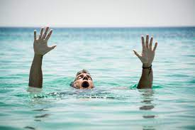 drown

I owe you my life. – Dugujem ti svoj život.
You saved my life. – Spasio si mi život.
remember – zapamtiti
forget - zaboraviti

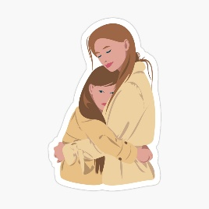 They hugged each other.

Choose the correct answer. (Izaberi točan odgovor.)
1 What does James write on the sand?
- My friend slapped me today.
- My friend hugged me today.
2 What does James write on the stone?
- My friend saved my life.
- My friend lied to me.
3 Friends should … the good things about their friendship.
- remember
- forget
4 Friends should … the bad things about their friendship.
- remember
- forget

