THIS IS THE WAY
THIS IS THE WAY 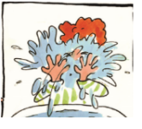I WASH MY FACE.
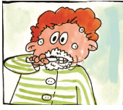I CLEAN MY TEETH.
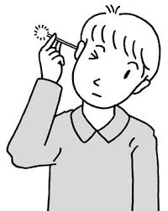I CLEAN MY EARS.
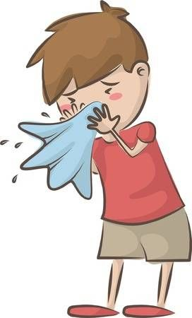 I BLOW MY NOSE.
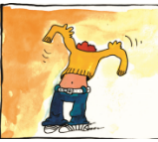 I PUT ON MY CLOTHES.
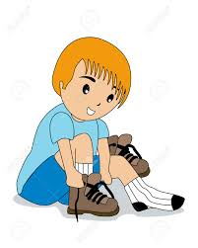 I PUT ON MY SHOES.
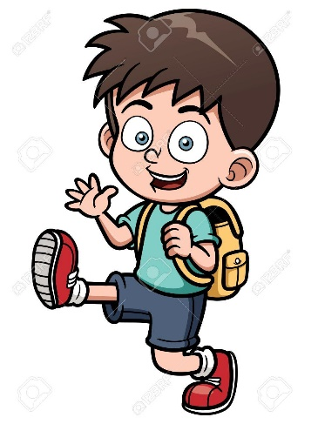 I GO TO SCHOOL.
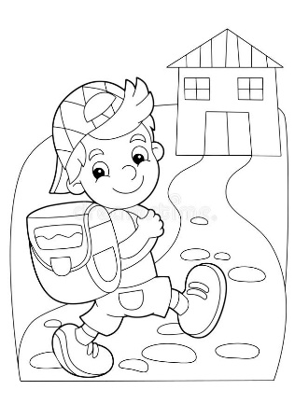 I GO HOME.

