What can you do in order to take care of our planet?
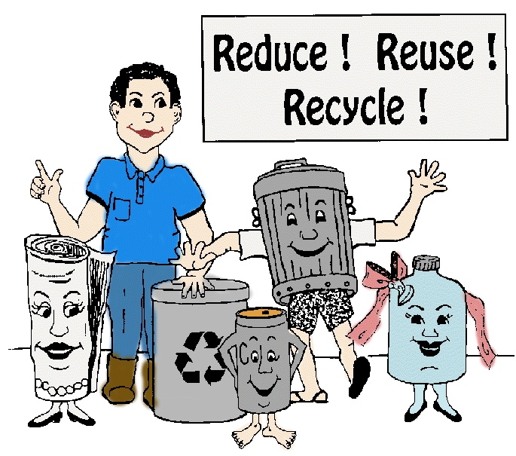

- turn off the light/the water
- turn off your computer and TV
- take short showers
- recycle plastic bottles, paper and cans
- use a glass instead of to-go cup
- don’t go by car; walk or go by bike
- protect animals
- plant trees

