**Describe the picture.**

**Use “There is/are someone/something + - ING.**

E. g.: There are two people **sitting** on the bench.

[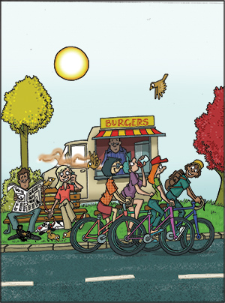](https://www.google.hr/url?sa=i&rct=j&q=&esrc=s&source=images&cd=&cad=rja&uact=8&ved=2ahUKEwiK1aDBksTZAhWLYlAKHV-eA8EQjRx6BAgAEAY&url=https://elt.oup.com/student/project/level4/unit04/grammar/exercise2?cc%3Dfr%26selLanguage%3Den&psig=AOvVaw2RskvNgX0x6_mtZvVV2OWa&ust=1519753683443523)