VITAMIN CHART
VITAMIN | Good for... | You get it from...
A | -skin and eyes | -orange fruit and vegetables,  -dark green vegetables  -eggs and milk
B | -energy  -muscles | -bread  -fish  -meat  -eggs  -beans 
C | -skin  -fights infections | -fruit (orange, grapefruit, tomatoes, potatoes)  -vegetables (cabbage, broccoli)  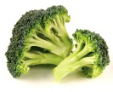
D | -teeth  -bones | -sunshine   -fish and eggs
E | -lungs and liver | -bread  -green vegetables  -eggs  -nuts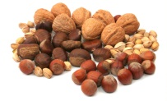  -oily fish (sardines and salmon)  