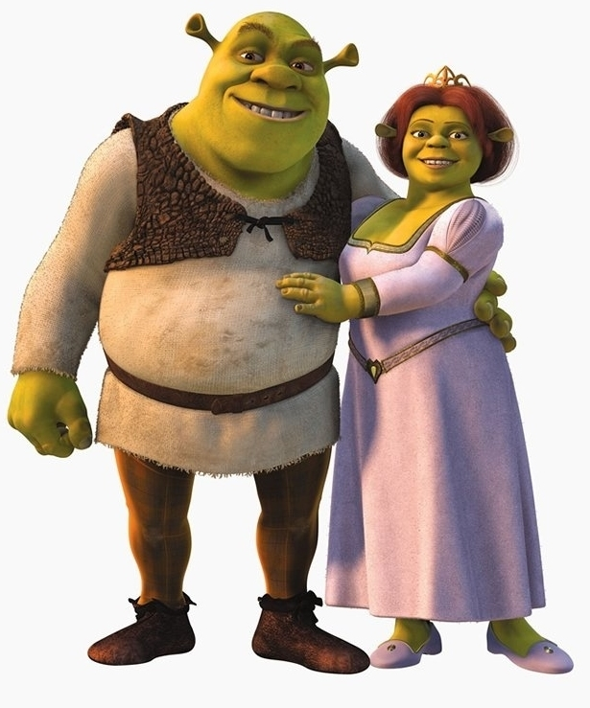

Fiona

Shrek

|  |  |
| --- | --- |
| This is Shrek. | This is Fiona. |
| He is old. | She is young. |
| He is tall and fat. | She is tall and plump. |
| He is bald. | Her hair is long and straight. |
| His eyes are big. | Her eyes are big and green. |