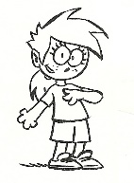
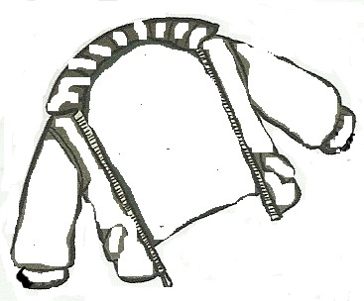
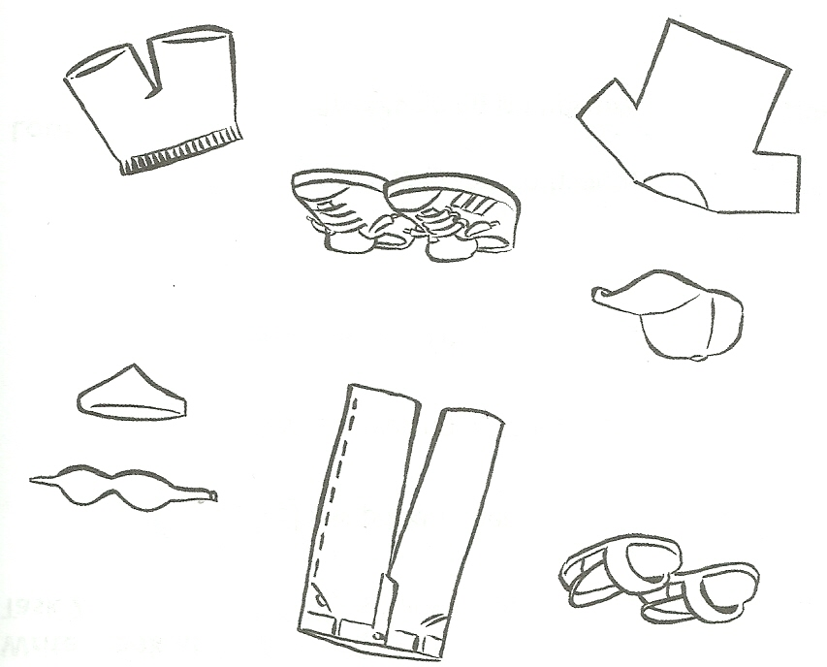
_________________________________________________________________________________
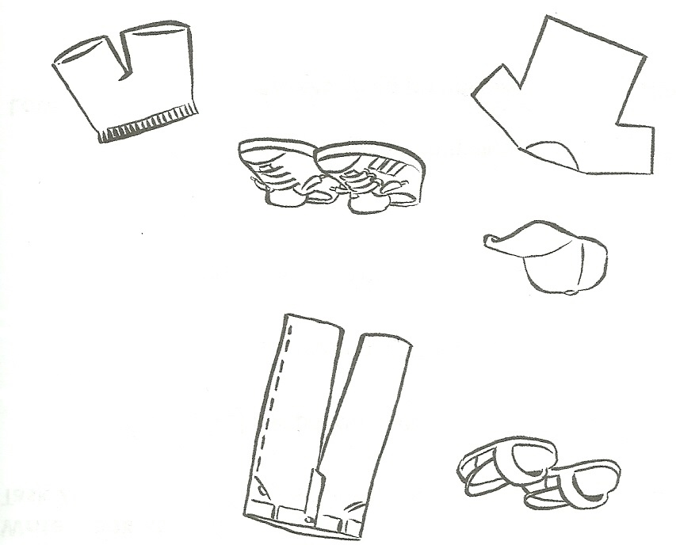
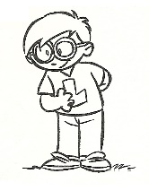
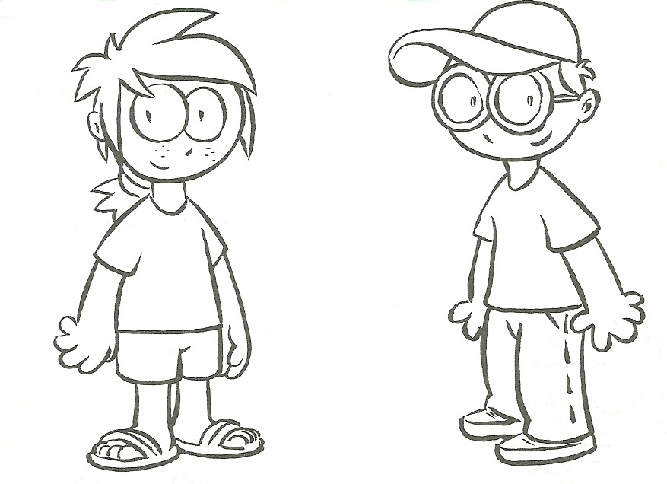

HOMEWORK
Her | sandals  shorts  T-shirt | is  are | red.  blue.  green.  orange.  white.  violet.  pink.  yellow.  brown.  black.

His | jeans  trainers  T-shirt  cap | is  are | red.  blue.  green.  orange.  white.  violet.  pink.  yellow.  brown.  black.

