WHAT’S THE TIME?

1 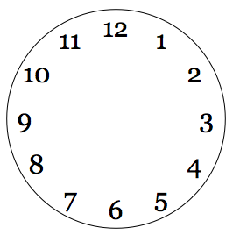 2 3

4 5 6

8 9
7

