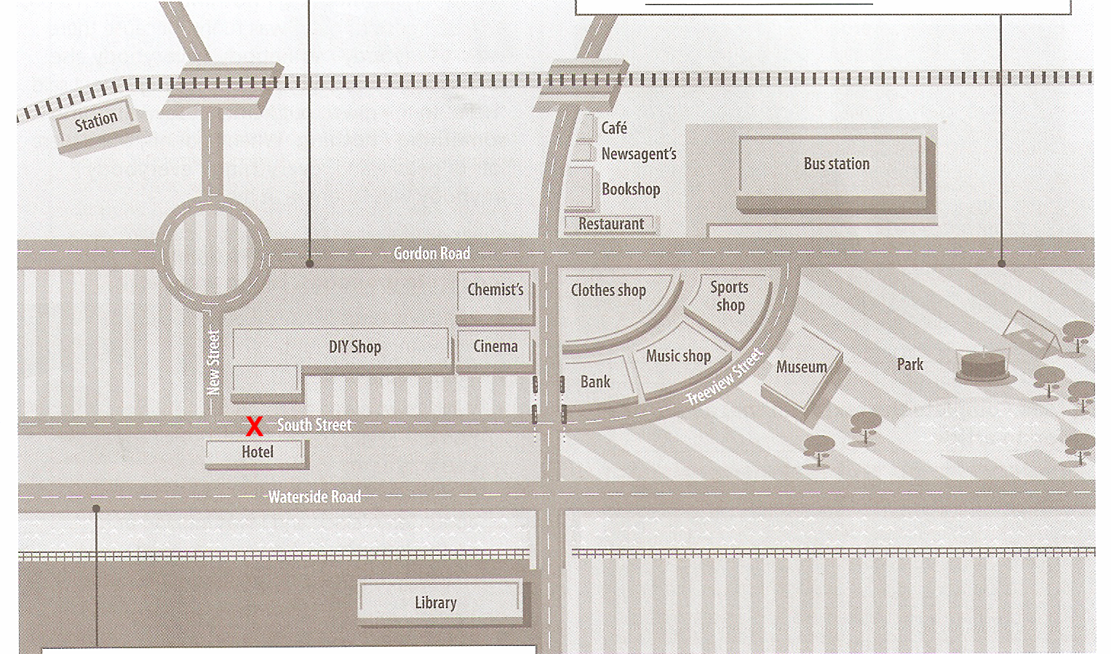

You are standing in front of the hotel.

A: Excuse me, _______________ to the bus station, please?

B: Go along here till you come to the ______________.Turn ________ at the traffic lights. Go down there and take the _________________ on the right. That’s Gordon Road. Go along that road and the bus station is on ______________, ______________ the park.